# Exam: Web Application (3 Hr.) –

**Requirements**

- Angular Version >= 14.X or newer

- NodeJS >= 14.X.X or newer

- ArcGIS Maps SDK for JavaScript >= 4.X or newer

- Visual Studio Code >= 1.69 or newer

**Assets Resources**

<https://github.com/mariczone/exam_web_assets> **Landing Page**

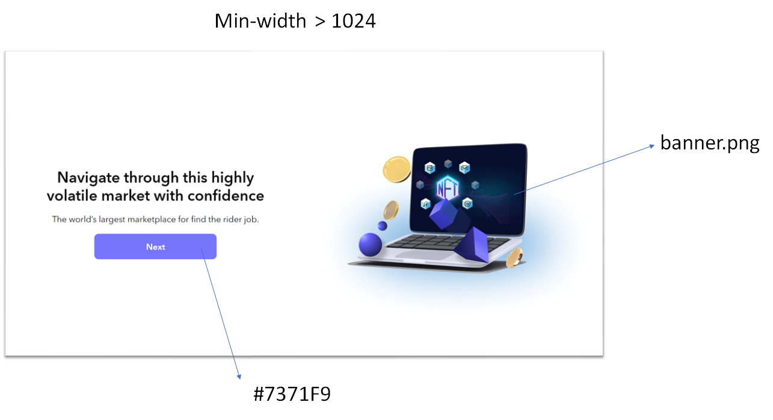

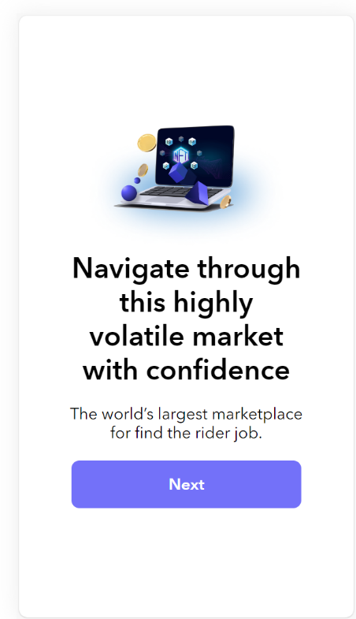

**Tasks**

* Implement responsive UI as above.
* When clicking on the “Next” button navigate to “/zone” route page

**Zone Page**

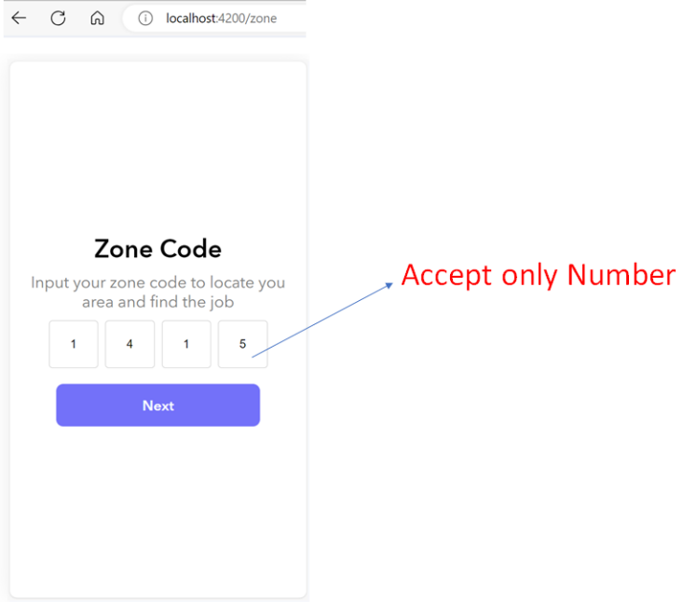

**Tasks**

* Implement the UI as above.
* Bind the click event to “Next Button” to validate the input. When it meets the requirement then navigate to the “/rider” page.
* Pass or share the “Zone Code (Ex. ‘1415’)” Value to use it on the last page.

**Validating**

* If the Zone code isn’t fulfilled with a 4 decimal number when clicking the next button, please alert message “Please fulfill zone code.” as below.

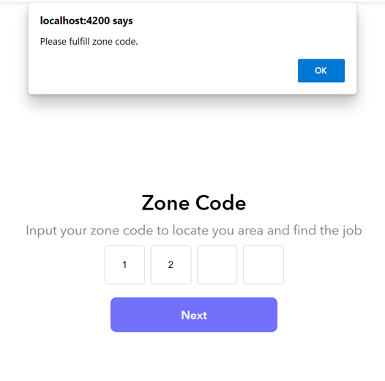

**Rider Page**

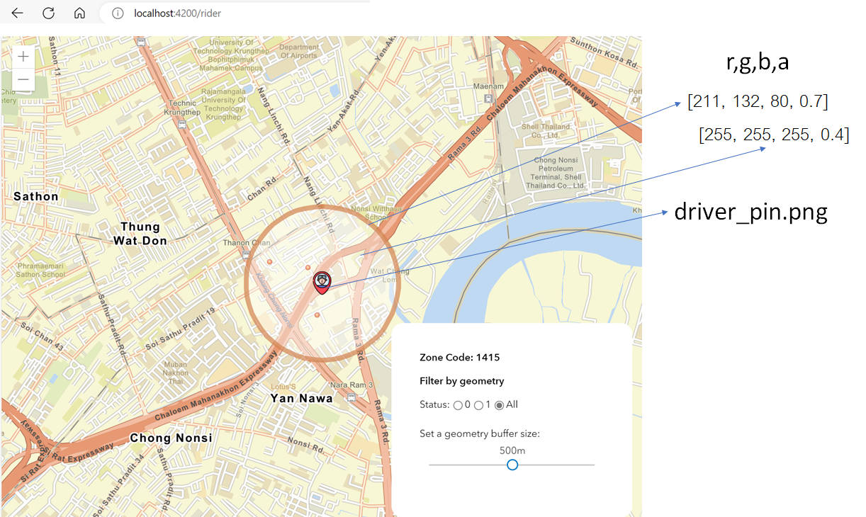

**Tasks**

* Implement the UI with Map as above.
* Initial Map zoom to the location (longitude: 100.543535058, Latitude: 13.703101959)
* Display Zone Code from the Previous Page

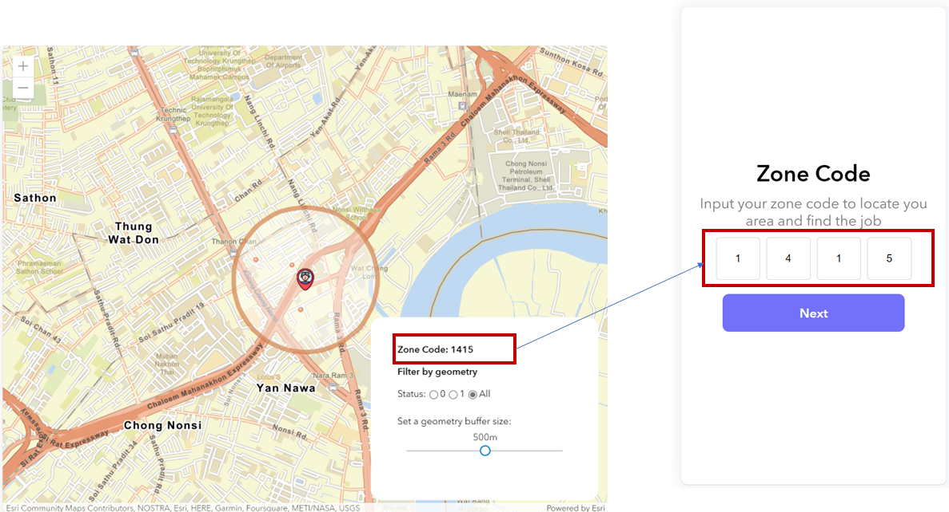

* Add the Driver's Pinpoint with a Picture Symbol at a specific location (longitude: 100.543535058, Latitude: 13.703101959)

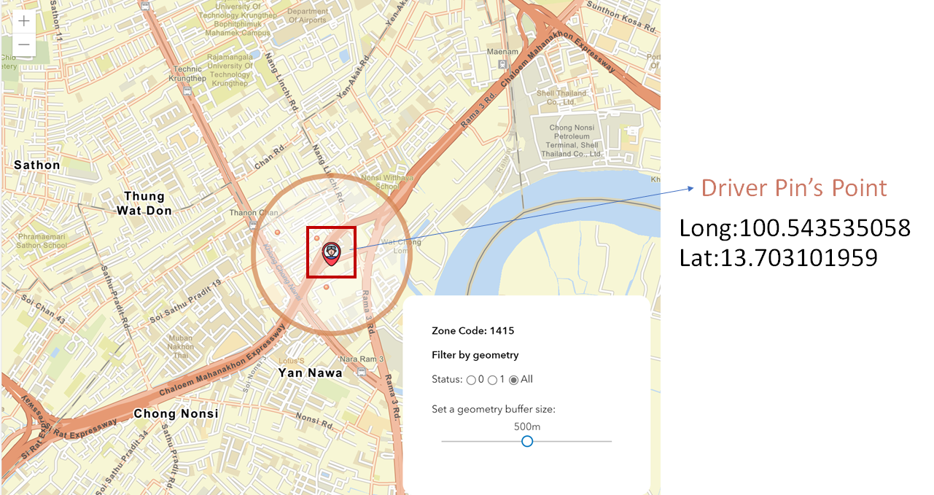

* Create a Buffer Panel and default create a buffer area 500 meters from the Driver's Pinpoint at the start.

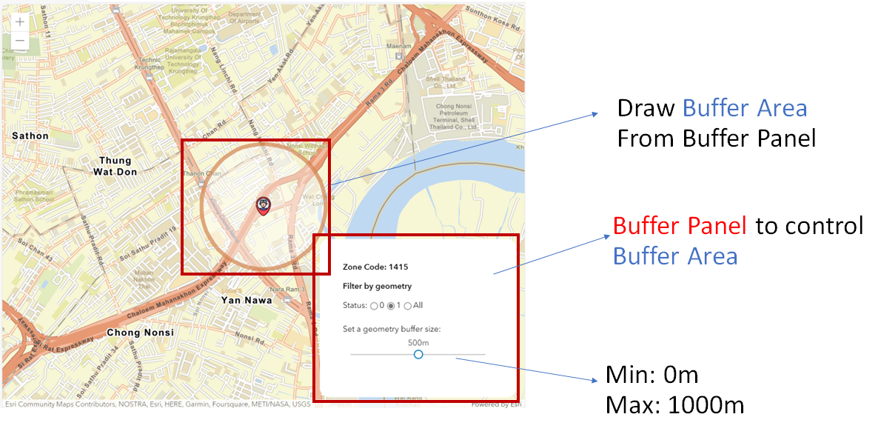

* Query the data from the feature layer ( <https://services8.arcgis.com/1GMGEQ46pmP4Y2wd/arcgis/rest/services/JOB_ZONE_LAYER/FeatureServer/0> ) with specific conditions and display the Job data on the Graphic Layer

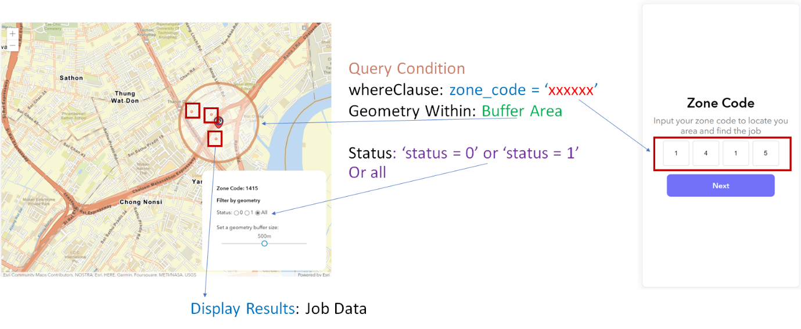

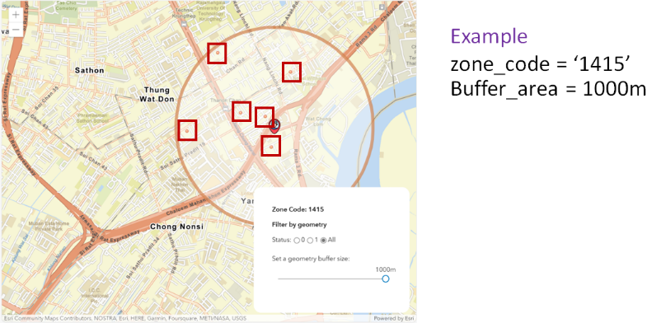

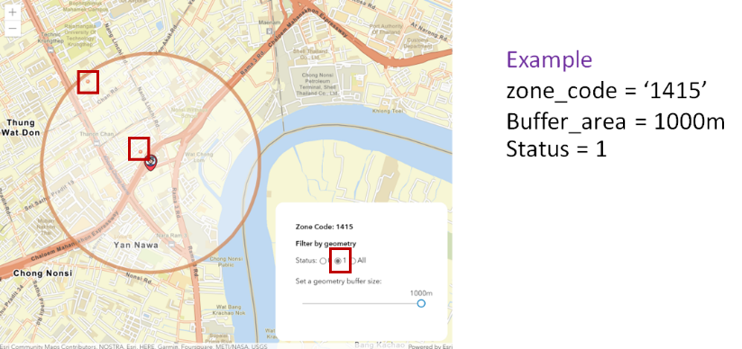

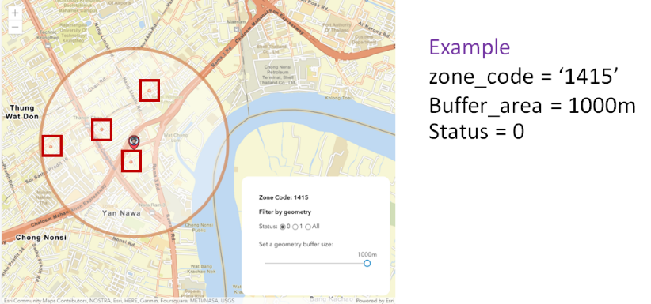

* Show Attribute Popup as below when clicking on data point

